Construcción de Mesa
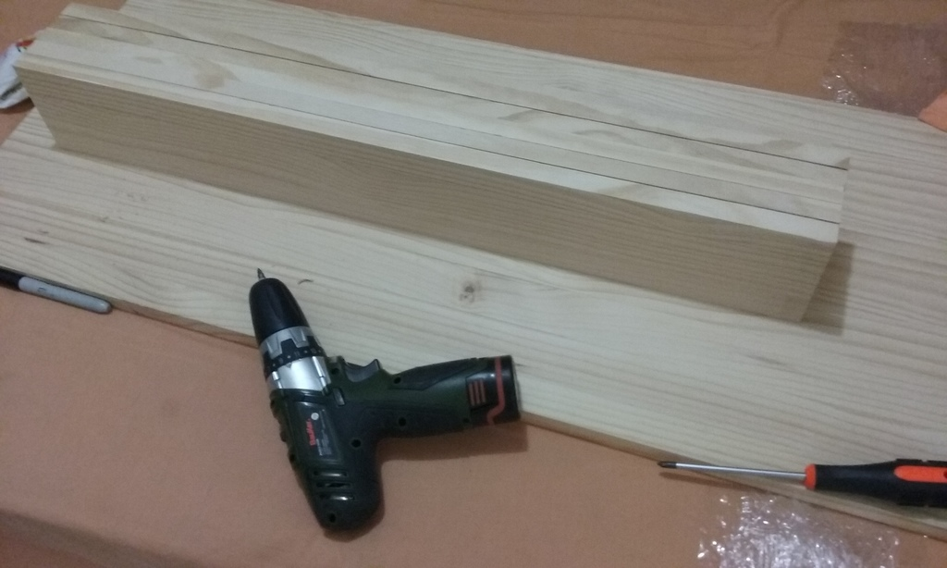 20161015_122835 20161015_122922 20161015_123017 20161015_123311 20161015_124035 20161015_124107 20161015_124245 20161015_124251 20161015_124648 20161015_124651 20161015_124701 20161015_124702 20161015_124713 20161015_124747 20161015_130557 20161015_132810 20161015_133041 20161015_135242 20161015_135249 20161015_135303 20161015_135336 20161015_135343 20161015_140134 20161015_140154 20161015_140156 20161015_152124 20161015_152146 20161015_155150 20161015_155200 20161015_155205 20161015_155231 20161015_155254 20161015_155257 20161015_155258

