Contador Personas
- Nuestro fork →
- Basado en proyecto → https://github.com/cyberman54/ESP32-Paxcounter
- 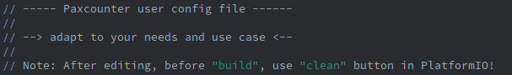
- LILYGO® TTGO MINI 32 V2.0 ESP32 WiFi bluetooth Module
- 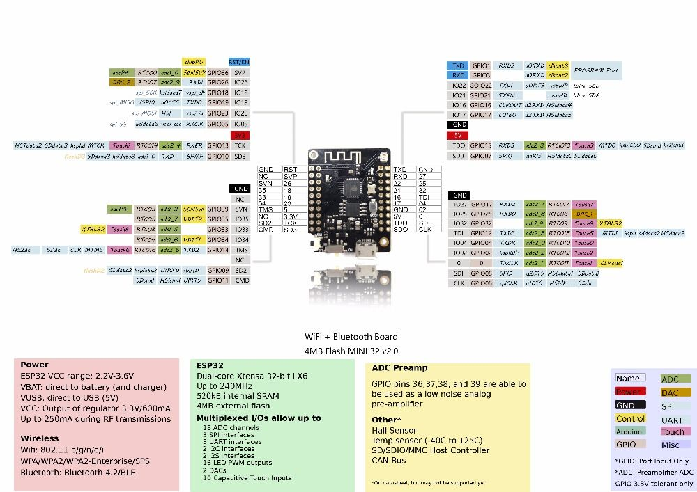
- Project issue 299: Add configurations to send data over wifi → https://github.com/cyberman54/ESP32-Paxcounter/issues/299
- Project issue 331: Running the program on a simple ESP32 board (without Lora) → https://github.com/cyberman54/ESP32-Paxcounter/issues/331
- Project issue 612: Bluetooth: observations/questions → https://github.com/cyberman54/ESP32-Paxcounter/issues/612
- Cambiar versión en platformio.ini 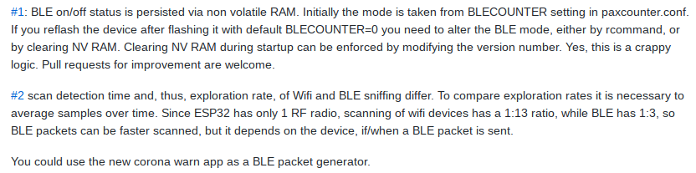
- https://github.com/cyberman54/ESP32-Paxcounter#sd-card
- Add support for 64×48 display, now it is only supported 128×64 (display.cpp)

Referentes
- Flujo del aire → https://www.theatlantic.com/health/archive/2020/07/why-arent-we-talking-more-about-airborne-transmission/614737/

