Configuración de dokuwiki con acceso OAuth
- Abra Google Developer Console en el navegador y ingrese con las credenciales de su cuenta.
- Click Create project… (you may see the page like this http://snag.gy/MZaOh.jpg).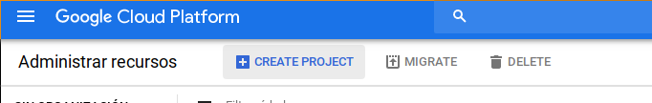
- Fill new project form, give some name and project ID (see http://snag.gy/Ipmxr.jpg).
  - Google may ask you to confirm you contact phone with SMS or callback. “Evil Corporation” define their own rules. It's up to you to decide :) 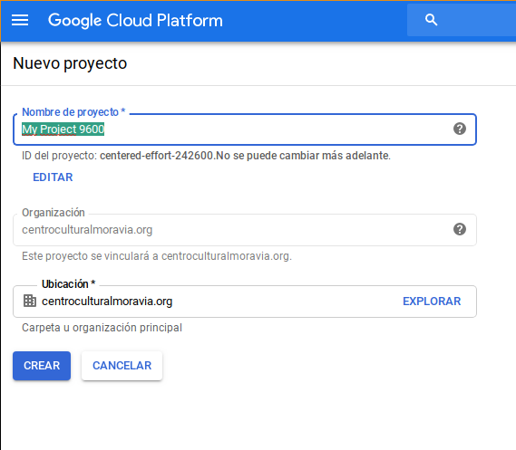
- Open menu APIs & auth → Credentials (see http://snag.gy/ZuLfU.jpg) 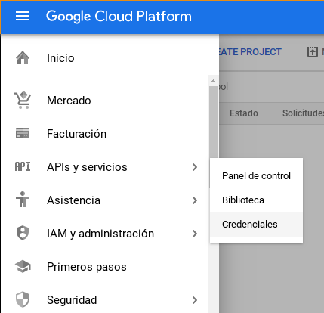
- Form “Create Client ID” will be opened. Fill it:
  - Application type: (required) choose “Web application”;
  - Authorized JavaScript Origins enter your hostname (make sure http or https is the same for both settings). For example:
http://www.your-domain.com
  - Authorized Redirect URIs enter these lines:
http://www.your-domain.com/doku.php?id=start&do=login
http://www.your-domain.com/start?do=login
http://your-domain.com/doku.php?id=start&do=login
http://your-domain.com/start?do=login
http://www.your-domain.com/doku.php/start?do=login
http://your-domain.com/doku.php/start?do=login
Instead of “your-domain” put your actual hostname where DokuWiki is installed. Note: if your DokuWiki is accesed with HTTPS then enter the URI with https, not http. 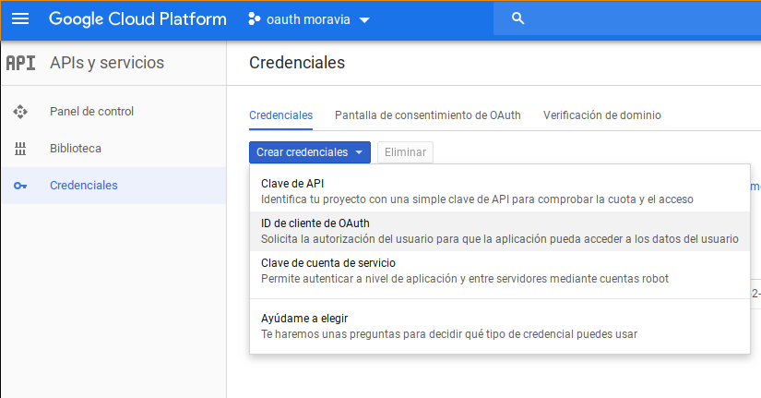 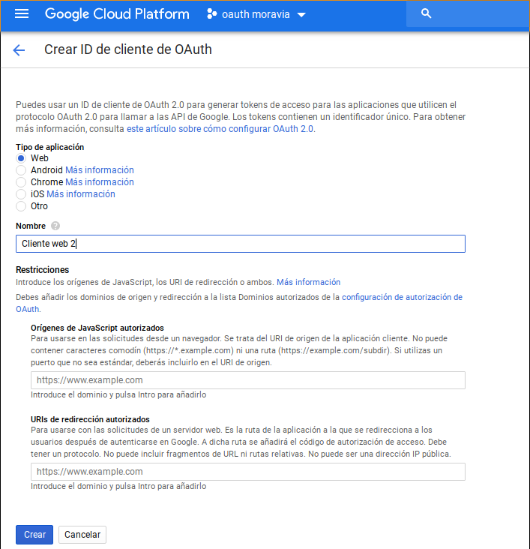
- Click “Create client ID” button.
- Now you have page with all required information for plugin setup. You will need two values from here: Client ID and Client secret.
- Open menu APIs & auth → Consent screen.
- Validar dominio 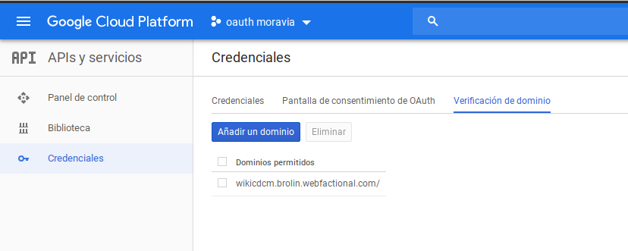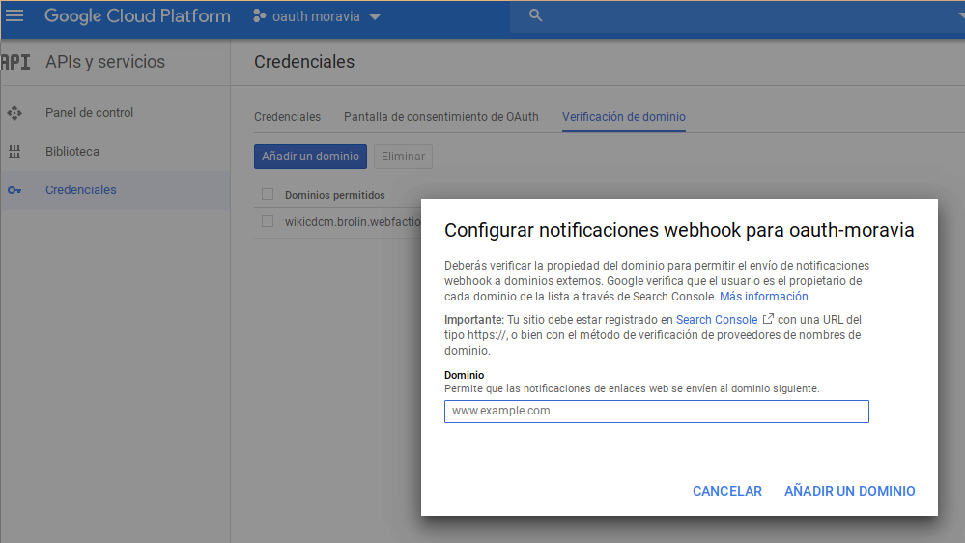
- Fill “PRODUCT NAME” and e-mail address as well, or you can get this error http://stackoverflow.com/questions/18677244/error-invalid-client-no-application-name.

Enlaces
- https://www.dokuwiki.org/auth
- https://developers.google.com/identity/protocols/OAuth2UserAgent?hl=es
- El plugin instalado → https://www.dokuwiki.org/plugin:oauth
- Se configuró como se explica acá → https://www.dokuwiki.org/plugin:authgoogle
- https://support.google.com/webmasters/answer/9008080?authuser=2&authuser=2&authuser=2&visit_id=636945871649970892-4181131069&rd=2

