Análisis de Datos
Population lines, idea de los gradientes de Dani → http://spatial.ly/2017/04/population-lines-how-and-why-i-created-it/ https://www.r-bloggers.com/joy-division-population-surfaces-and-pioneering-electronic-cartography/
joyplot with d3 https://beta.observablehq.com/@mbostock/d3-ridgeline-plot
horizon chart with d3 https://beta.observablehq.com/@mbostock/d3-horizon-chart
When projections showed Hurricane Harvey could bring a record setting amount of rain to Houston, the graphics desk at the New York Times started exploring ways of showing the rainfall. After a couple of days of scrambling, we managed to make a map showing both the accumulation and rate of rainfall: → https://roadtolarissa.com/hurricane/
Use a data analytics tool to predict where the Pokemon are going to appear → https://www.pluralsight.com/guides/big-data/use-a-data-analytics-tool-to-predict-where-the-pokemon-are-going-to-appear
a visualization of global weather conditions forecast by supercomputers updated every three ours → https://earth.nullschool.net/about.html https://github.com/cambecc/earth http://www.copernicus.eu/
Using machine learning to identify air pollution exposure profiles associated with early cognitive skills among U.S. children → http://www.sciencedirect.com/science/article/pii/S0269749117313027
This playground exists to showcase a type of Swarm Intelligence known as Flocking. → https://tech.io/playgrounds/1003/flocking-autonomous-agents/going-further
JSGeo2017 → https://www.dropbox.com/s/xak1kodwly80z8z/JSGeo2017.pdf?dl=0
R package to analyze air quality data → https://www.r-bloggers.com/rtimicropem-using-an-r-package-as-platform-for-harmonized-cleaning-of-data-from-rti-micropem-air-quality-sensors/ https://ropensci.org/blog/blog/2017/02/21/ropenaq https://www.r-bloggers.com/working-with-air-quality-and-meteorological-data-exercises-part-2/ https://www.r-bloggers.com/working-with-air-quality-and-meteorological-data-exercises-part-4/
Grupo en valencia, españa → http://safe-tools.dsic.upv.es/airvlc/data-analysis.php https://valenciarusers.files.wordpress.com/2016/04/prediccic3b3n_contaminacic3b3n-lidiacontreras.pdf Los datos que tenemos pueden ser muy similares a estos que se obtienen a partir de strava → https://github.com/marcusvolz/strava
Fondo para una serie de tiempo con escala ICA https://media.licdn.com/mpr/mpr/jc/AAEAAQAAAAAAAAX4AAAAJDIxYTFjMzEzLWUzNzEtNDgzOS1iZDVlLTY4OTgzZTBmZWQxYw.png
Mapa 3d para visualizar mediciones http://www.seattlebikeblog.com/wp-content/uploads/2014/03/SBB_pollution_map-575x471.png origen de este mapa https://www.researchgate.net/publication/252731674_Exposure_of_Bicyclists_to_Air_Pollution_in_Seattle_Washington_Hybrid_Analysis_Using_Personal_Monitoring_and_Land_Use_Regression Podría implementarse con : http://rgraphgallery.blogspot.com.co/2013/05/rg107-plot-3d-horizontal-lines-bars.html
Artículo CSWA: Aggregation-Free Spatial-Temporal Community Sensing → https://arxiv.org/pdf/1711.05712v1.pdf
Viento y PM25 → http://aqicn.org/faq/2015-11-05/a-visual-study-of-wind-impact-on-pm25-concentration/
Predicción de concentración PM25 usando redes neuronales https://www.sciencedirect.com/science/article/pii/S1352231015001491
Anomaly detection with R → https://www.r-bloggers.com/anomaly-detection-in-r-2/
Animación de la contaminación en china → https://old.reddit.com/r/dataisbeautiful/comments/8v0m98/oc_3d_animation_of_chinas_nitrogen_dioxide/
Predicting Sunspot Frequency with Keras LSTM In R → https://www.r-bloggers.com/time-series-deep-learning-part-2-predicting-sunspot-frequency-with-keras-lstm-in-r/
Metaballs → http://jamie-wong.com/2014/08/19/metaballs-and-marching-squares/
AgentMaps - Social Simulations on Interactive Maps → https://noncomputable.github.io/AgentMaps/
Fans Energy Viz → https://reimaginethegame.economist.com/en/matches/bayern-gladbach/fans
Privacy mobility → https://techxplore.com/news/2018-12-privacy-mobility.html
Proof-of-location → https://www.theatlantic.com/technology/archive/2018/11/can-blockchain-maps-replace-gps/576985/
RETIGO Epa → https://www.epa.gov/hesc/real-time-geospatial-data-viewer-retigo

Visualización interactivas

Query engine
- https://medium.com/coinograph/storing-and-processing-billions-of-cryptocurrency-market-data-using-influxdb-f9f670b50bbd
- https://docs.influxdata.com/influxdb/v1.6/query_language/continuous_queries/
- https://www.youtube.com/watch?v=0syXa8cBY-Y

Eventos externos
- Eventos externos como la interacción con la visualización llegan por websockets y se convierten en eventos del mouse
- http://nmajor.com/posts/using-socket-io-with-redux-websocket-redux-middleware

Estilo de la visualización
- Se propone un estilo radial para la serie de tiempo
- https://kmandov.github.io/d3-horizon-chart/
- https://beta.observablehq.com/@mbostock/d3-horizon-chart
- https://github.com/d3/d3-shape#areaRadial
- https://github.com/d3/d3-shape#area_curve
- http://blockbuilder.org/emeeks/b57f4cc89dacd38fcdcd
- http://blockbuilder.org/susielu/b6bdb82045c2aa8225f5
- https://bl.ocks.org/susielu/4c7a8a89a25bd86a61a8
- http://blockbuilder.org/emeeks/e47ced0d0c5516c6745b
- http://bl.ocks.org/nbremer/4b81aff1ff5907ac3db1780a1c6a5e01
- https://www.visualcinnamon.com/2017/10/creating-baby-births-visual
- http://sxywu.com/travel/
- https://stackoverflow.com/questions/44814519/d3-colour-gradient-not-forming-mathematical-circle-around-centre-of-area
- http://scottcheng.github.io/bj-air-vis/
- https://bl.ocks.org/davidwclin/ad5d13db260caeffe9b3
- http://datacanvas.org/sense-your-city/#!/data
- http://www.maartenlambrechts.com/2014/07/29/introducing-the-weather-browser.html
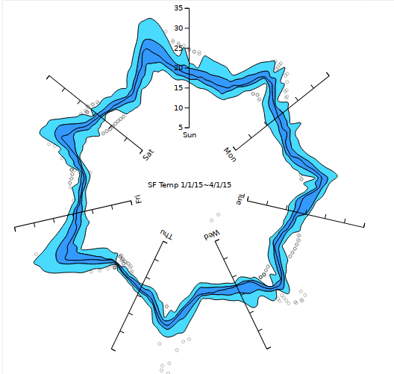
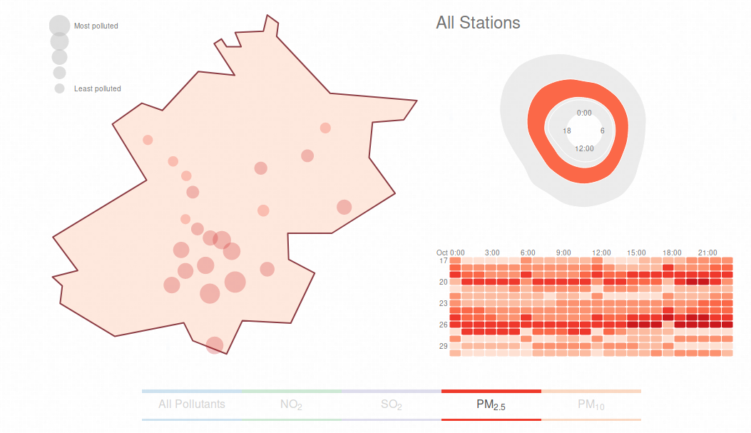
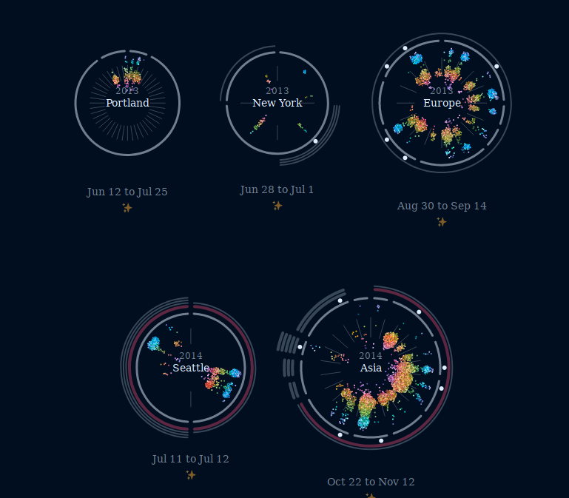

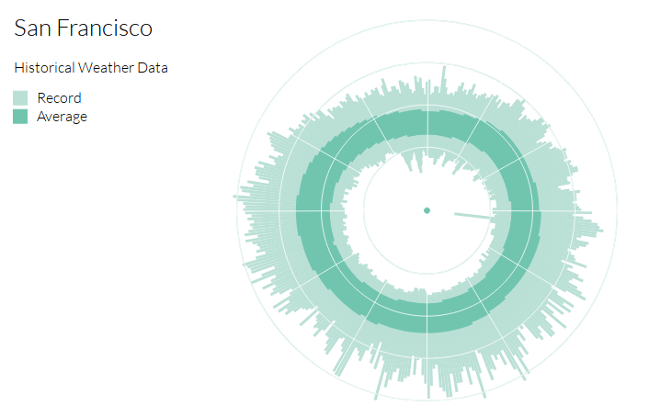
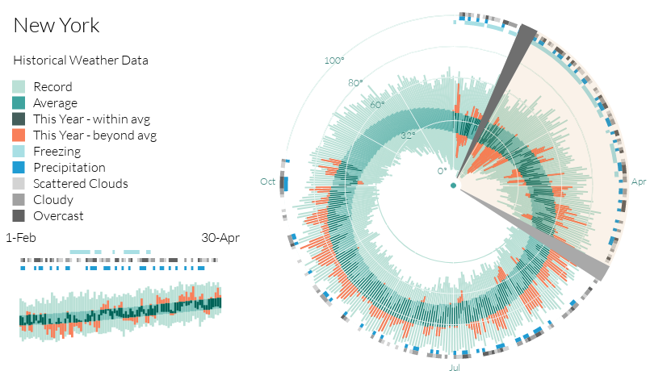
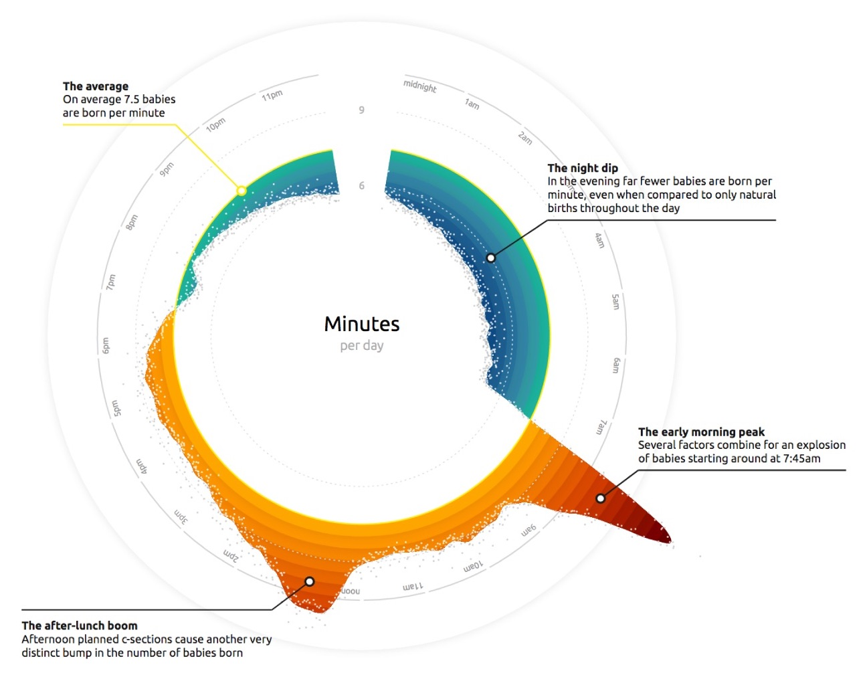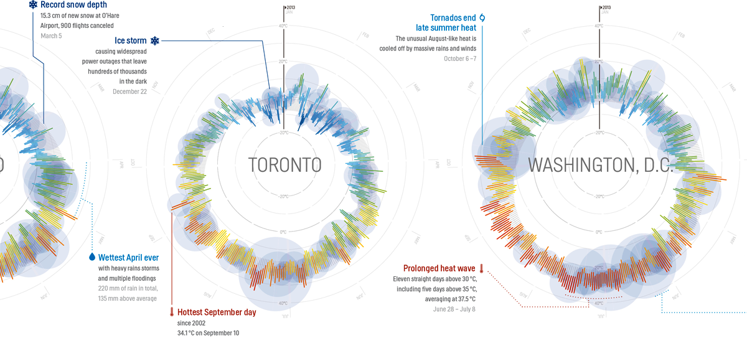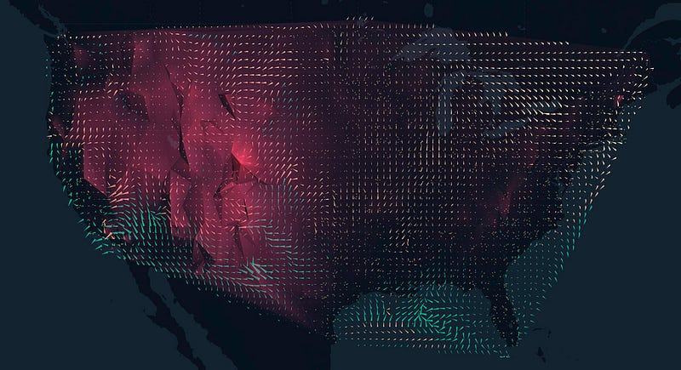

Posible superficie de proyección
De no se posible la proyección se puede ubicar un led en el lugar de la estación y que se ilumine según el promedio de la hora
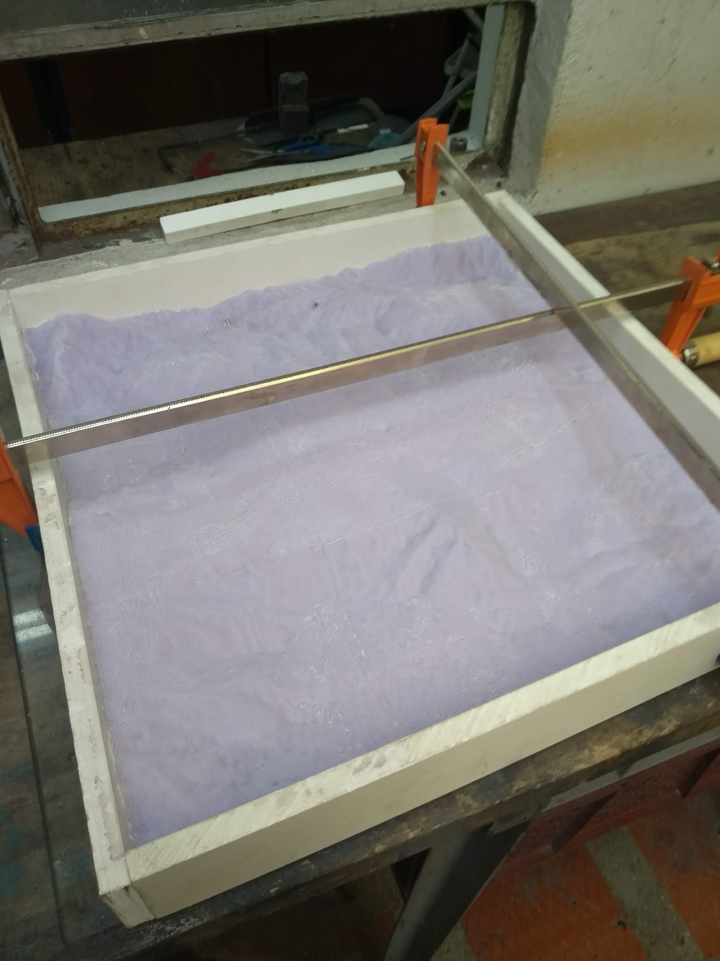
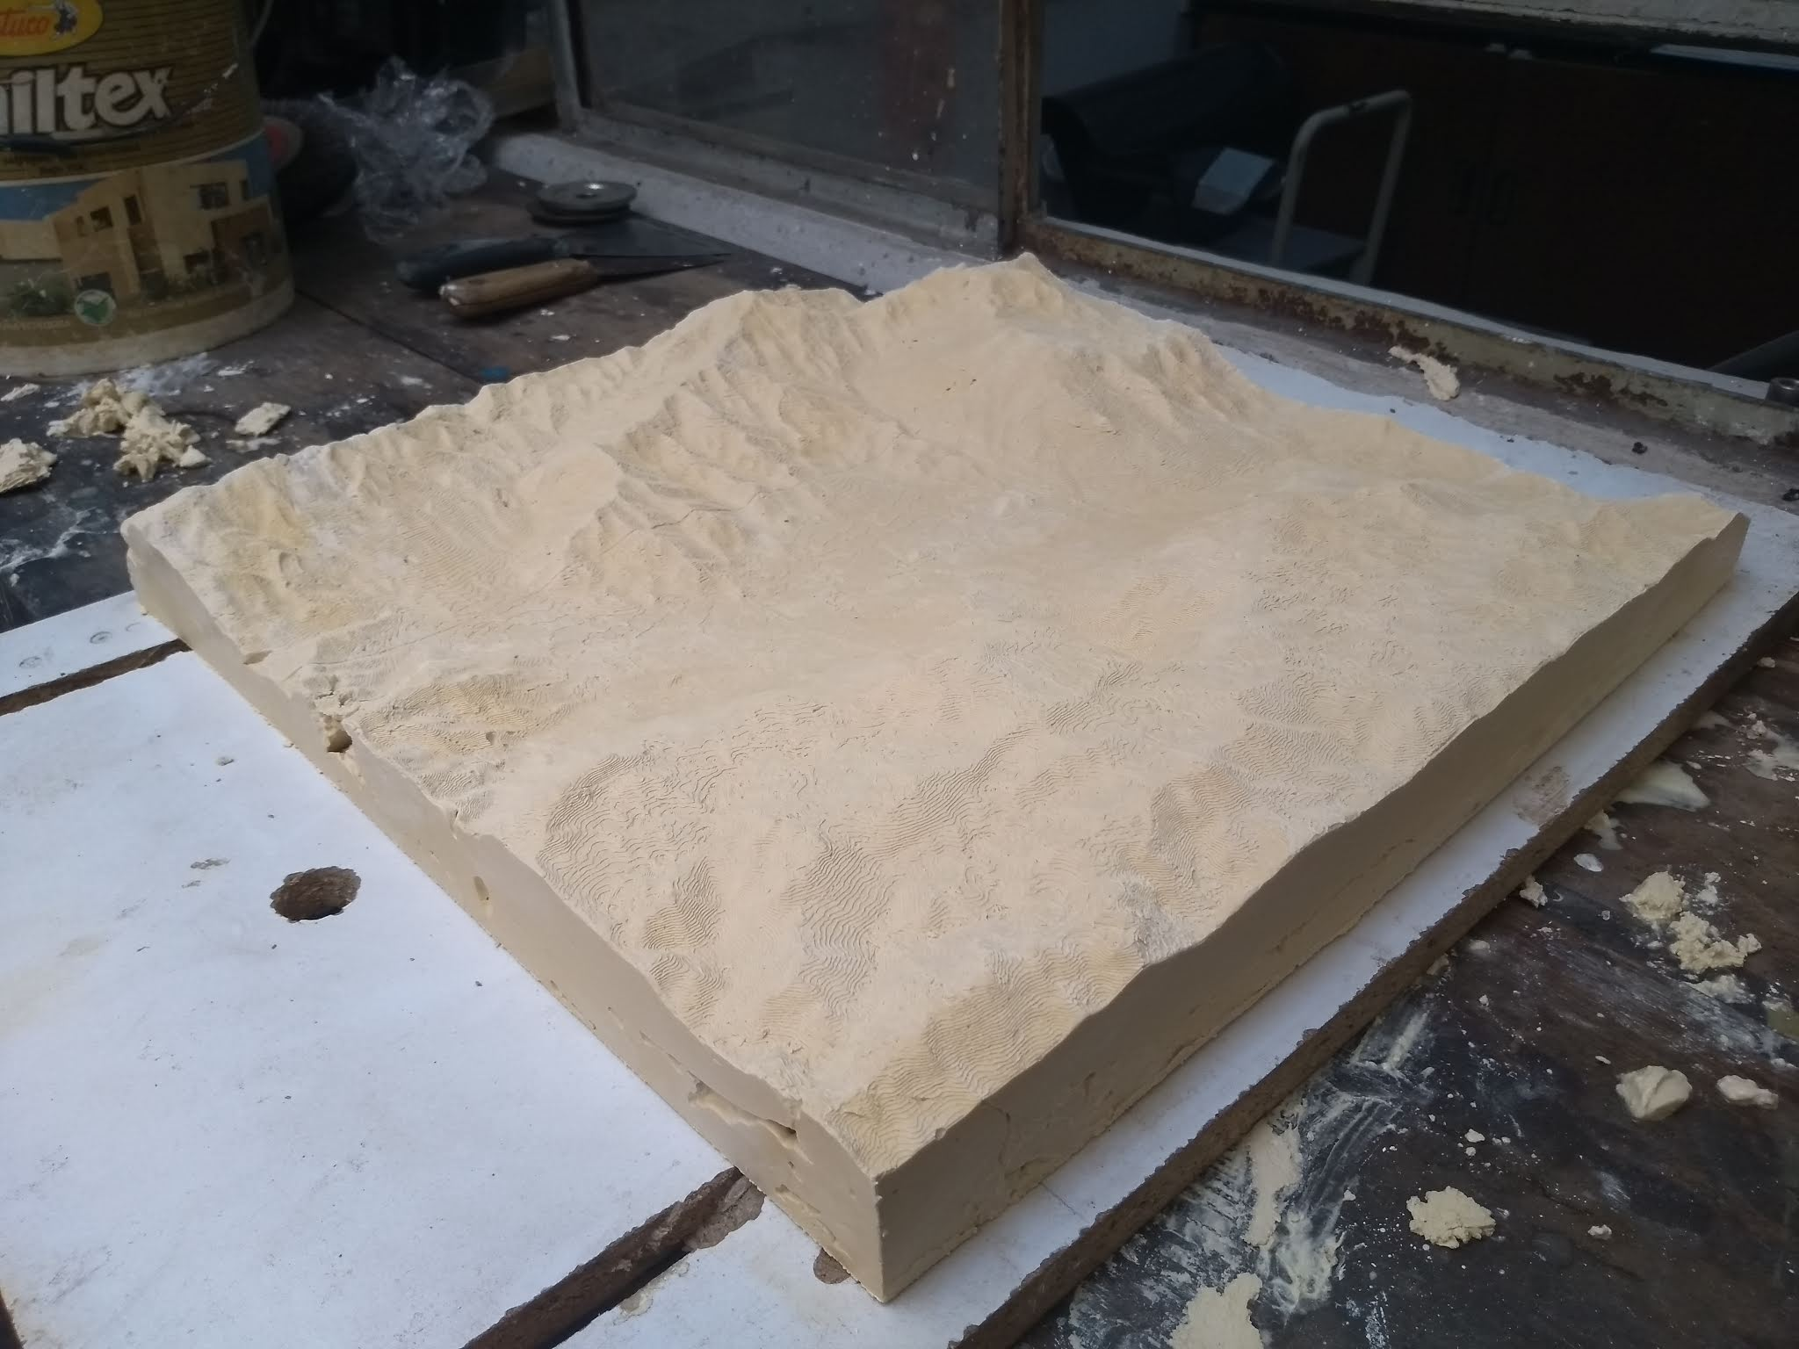
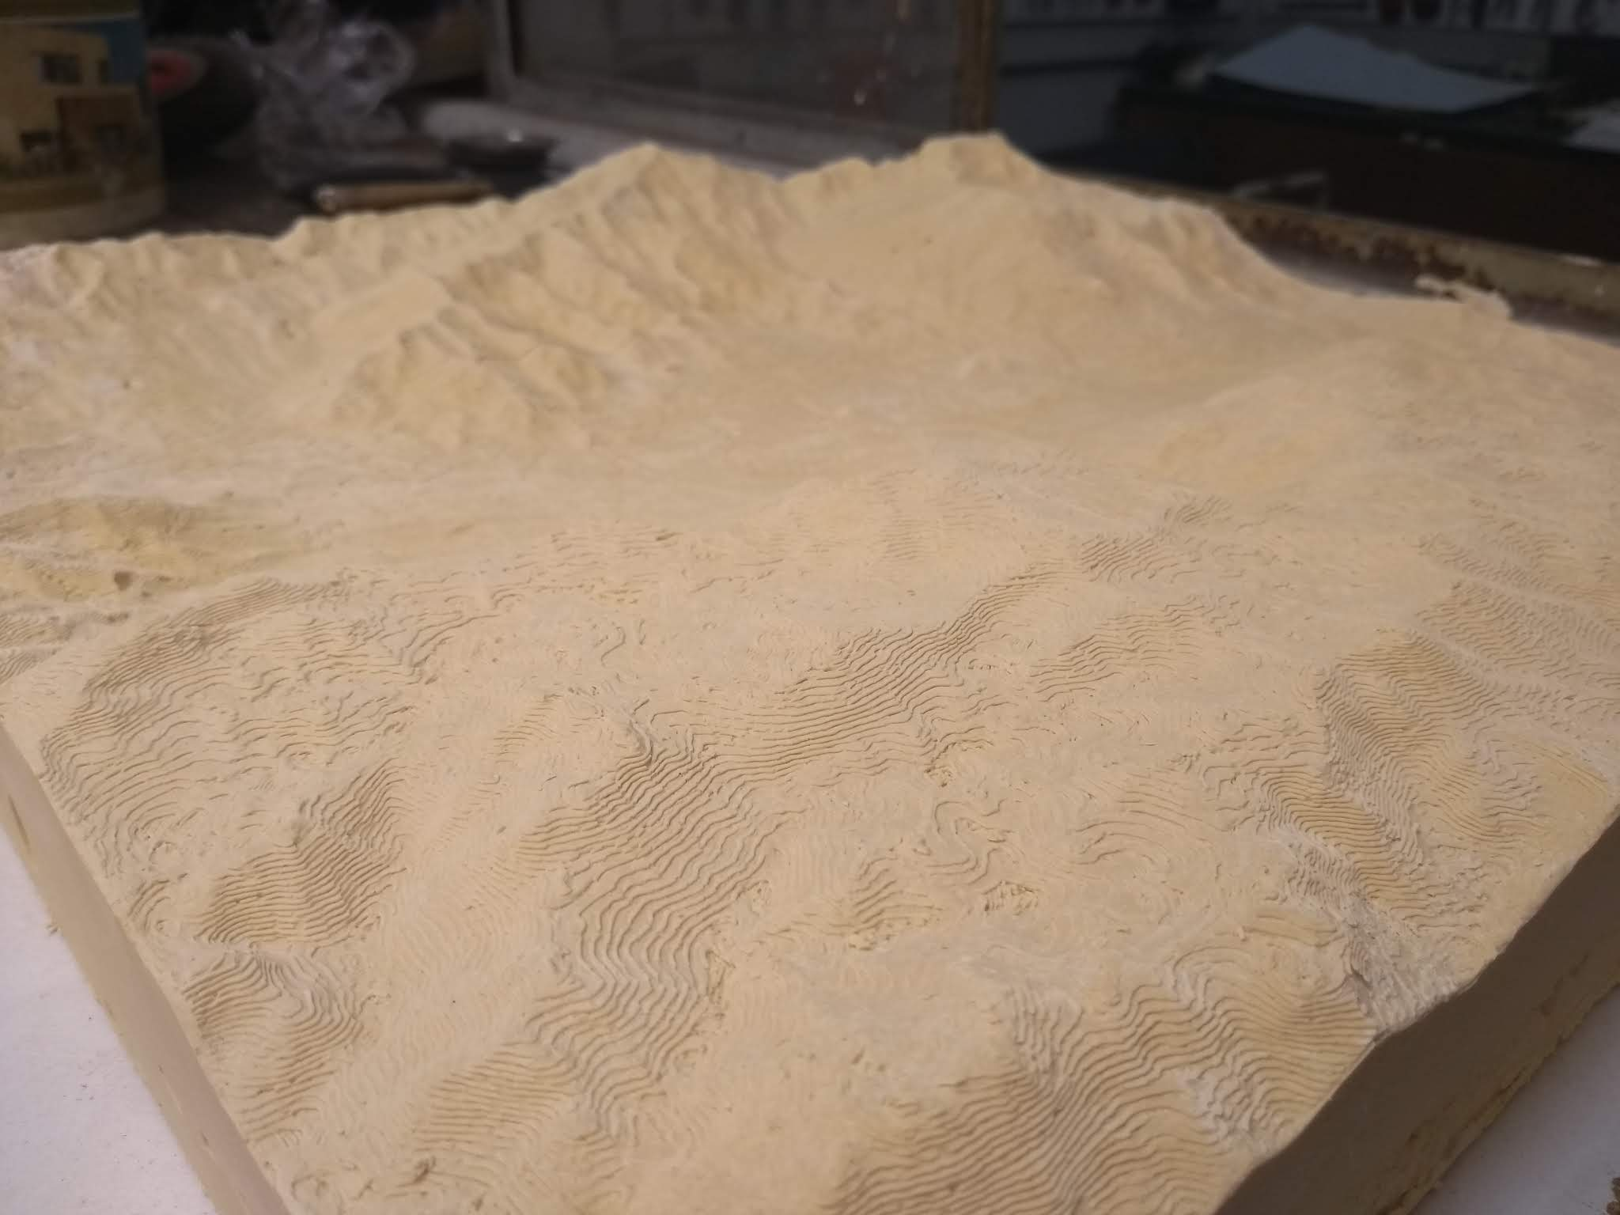

Privacidad
- https://edition.cnn.com/2019/07/09/tech/toronto-sidewalk-labs-google-data-trust/index.html

