Debugging de la trama de datos del sensor PMS5003
- Logic analyzer → http://vdwaa.nl/logic%20analyzer/pulseview/arch/linux/5-euro-usb-logic-analyzer/
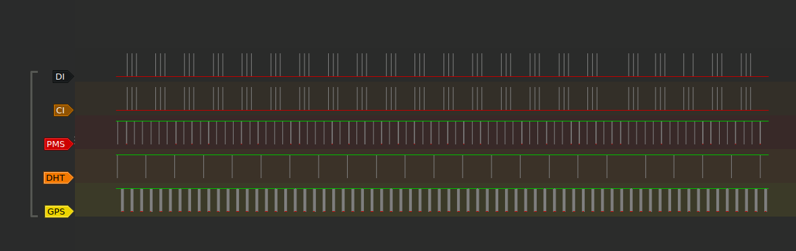
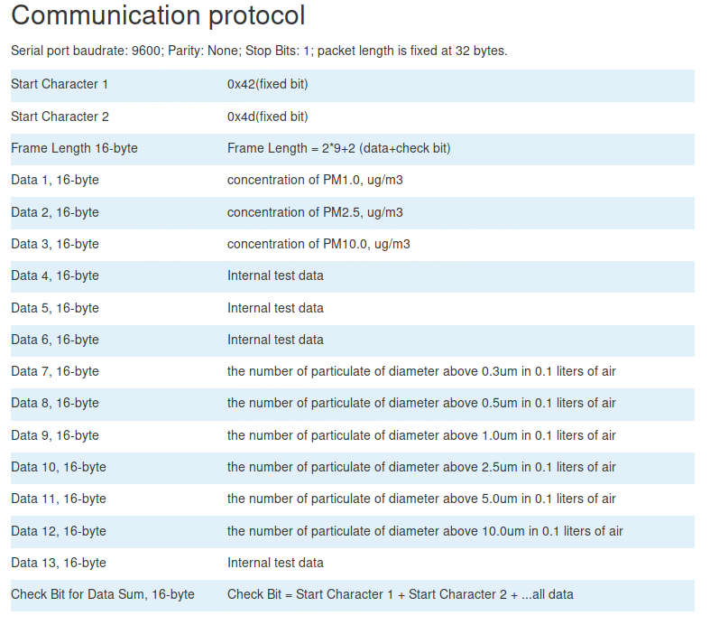
- https://www.dfrobot.com/wiki/index.php/Air_Quality_Monitor_(PM_2.5,_Formaldehyde,_Temperature_%26_Humidity_Sensor)_SKU:_SEN0233#Board_Overview
- https://www.dfrobot.com/wiki/index.php/PM2.5_laser_dust_sensor_SKU:SEN0177
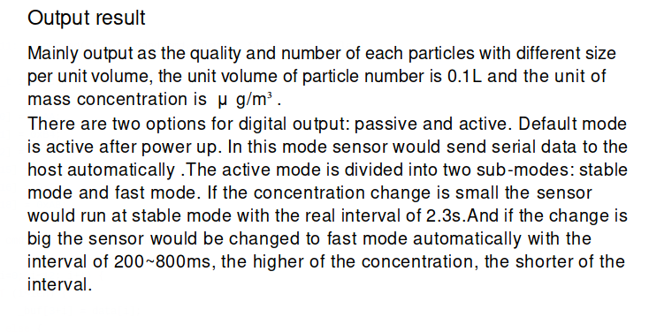
- Leer con detalle → http://www.aqmd.gov/docs/default-source/aq-spec/resources-page/plantower-pms5003-manual_v2-3.pdf?sfvrsn=2
- http://www.aqmd.gov/home/library/public-information/publications/aire-sucio

Sensor Accuracy
- http://www.aqmd.gov/docs/default-source/aq-spec/field-evaluations/purpleair---field-evaluation.pdf?sfvrsn=2
- http://www.aqmd.gov/docs/default-source/aq-spec/laboratory-evaluations/purple-air-pa-i---lab-evaluation.pdf?sfvrsn=2
- (Grimm vale EU$15K) Particle Distribution Dependent Inaccuracy of the Plantower PMS5003 low-cost PM-sensor - https://www.researchgate.net/publication/320555036_Particle_Distribution_Dependent_Inaccuracy_of_the_Plantower_PMS5003_low-cost_PM-sensor | http://wiki.grimm-aerosol.de/index.php?title=IAQ-11-R
- https://www.researchgate.net/publication/6754812_Comparison_of_the_GRIMM_1108_and_1109_Portable_Aerosol_Spectrometer_to_the_TSI_3321_Aerodynamic_Particle_Sizer_for_Dry_Particles → Pillar el diagrama del experimento
- Kit similar al nuestro https://airu.coe.utah.edu/sensors/ | https://docs.google.com/presentation/d/1sc_QHbBamYe9fkiuvdFguANOjlmAPU9huqi7g6odd8M/edit#slide=id.g18b062bcaa_0_58
- http://aqicn.org/sensor/pms5003-7003/
- https://uwspace.uwaterloo.ca/bitstream/handle/10012/12776/Tan_Ben.pdf?sequence=5
- https://ourairquality.org/index.php/build-an-air-quality-monitor/

Hardware
- Connector → https://romkey.com/2018/11/06/found-plantower-pms3003-pms5003-pms7003-connectors/

