Blockchain
- Explanation of blockchain → https://medium.com/better-programming/a-technical-introduction-to-blockchain-22ab05308151
Monetize Your Business With Your Users' CPU Power → https://coin-hive.com/
Beaker is a peer-to-peer browser with tools to create and host websites. Don't just browse the Web, build it. → https://beakerbrowser.com/
Blockchain based social media → http://www.maxkeiser.com/2017/06/steem-a-blockchain-based-social-media-rewards-platform/ https://steemit.com/
Breath (BRH) uses human respiration to mine crypto-currencies. → http://respiration.ltd/

Lightning Network
- Lightning is a layer-2 payment network built on top of layer-1, Bitcoin. This layer-2 network consists of nodes running the Lightning Network protocol, with bidirectional payment channels open between them. These payment channels allow for many fast payments to be made between nodes without the slower on-chain, layer-1 transactions. There is no need to wait for layer-1 block confirmations when making Lightning payments in established channels. Channels are opened and closed with an on-chain transaction while any number of Lightning payments can be made so long as the channels remain open and funded.
- Montaje de nodo de esta red → https://www.econoalchemist.com/post/build-a-self-custodial-lightning-node-with-raspiblitz#viewer-er5g1
- ¿Cómo verificar la firma GPG de la imagen descarga? → https://www.gnupg.org/gph/en/manual/x135.html https://armantheparman.com/gpg/
Download Raspberry Pi Foundation Public Keys from https://www.raspberrypi.org/raspberrypi_downloads.gpg.key
$ gpg --import raspberrypi_downloads.gpg.key
> gpg: key 8738CD6B956F460C: 1 firma no comprobada por falta de una clave
> gpg: clave 8738CD6B956F460C: clave pública "Raspberry Pi Downloads Signing Key" importada
> gpg: Cantidad total procesada: 1
> gpg: importadas: 1
> gpg: no se encuentran claves absolutamente fiables
$ gpg --verify 2021-05-07-raspios-buster-arm64.zip.sig 2021-05-07-raspios-buster-arm64.zip
> gpg: Firmado el vie 28 may 2021 09:00:36 -05
> gpg: usando RSA clave 54C3DD610D9D1B4AF82A37758738CD6B956F460C
> gpg: Firma correcta de "Raspberry Pi Downloads Signing Key" [desconocido]
> gpg: ATENCIÓN: ¡Esta clave no está certificada por una firma de confianza!
> gpg: No hay indicios de que la firma pertenezca al propietario.
> Huellas dactilares de la clave primaria: 54C3 DD61 0D9D 1B4A F82A 3775 8738 CD6B 956F 460C
- Build the SD card image → https://github.com/rootzoll/raspiblitz/tree/v1.7.0#build-the-sd-card-image
- Falla la sección PREPARING BITCOIN del build script, la versión actual es 0.21.1, parece que fue un problema temporal con el servidor donde estaba alojada la clave pública.
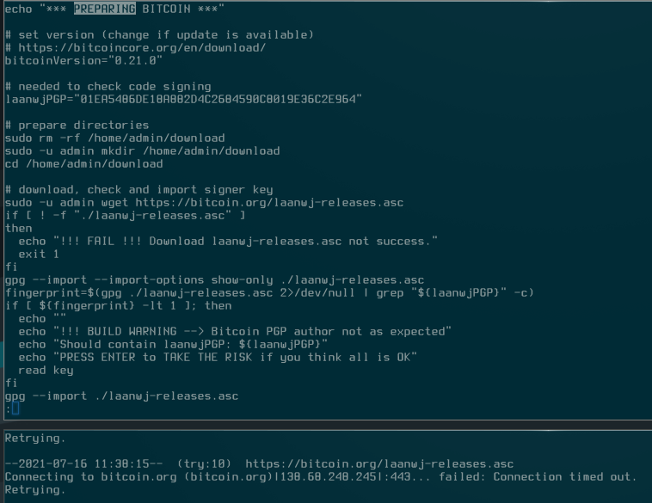
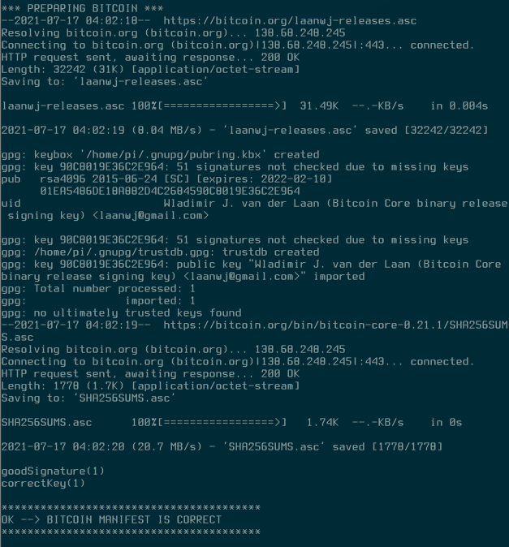

Install on amd64 hardware
https://github.com/rootzoll/raspiblitz/blob/v1.9/ci/README.md#flashing
$ unzip raspiblitz-amd64-image-2023-02-05-872707.zip
$ gzip -dkv raspiblitz-amd64-debian-lean.qcow2.gz
Attach OS_DISK via a sata to usb adapter, identify partitions and LVM volumes
$ lsblk -f
Flash qemu image directly to the disk
$ sudo qemu-img dd if=./raspiblitz-amd64-debian-lean.qcow2 of=/dev/sdb bs=4M
Once finished, resize the root partition of the final OS to the free space. First create a new partition with remaning space of the disk with gparted
Add this new partition to LVM
$ sudo pvcreate /dev/sdb3
Check how is called the Logical Volume Group
$ sudo vgdisplay
Extend the volume groud adding the new volume
$ sudo vgextend raspiblitz-amd64-debian-lean-vg /dev/sdb3
Resize the root logical volume to the remaning free space
$ sudo lvextend -r -l +100%FREE /dev/mapper/raspiblitz–amd64–debian–lean–vg-root
Connect the OS_DISK to the amd64 computer and power on connected to ethernet. Via ssh connect to the computer
$ ssh admin@LOCALNETWORK_IP
password: raspiblitz
Setup the node via raspiblitz menus
As in https://wiki.debian.org/iwlwifi add the component non-free after deb http://deb.debian.org/debian bullseye main in /etc/apt/sources.list
install the wifi driver for the mentioned cards:
$ sudo apt update && sudo apt install firmware-iwlwifi
Setup wifi connection https://www.makeuseof.com/connect-to-wifi-with-nmcli/
$ sudo nmtui

No hibernación
https://github.com/raspiblitz/raspiblitz/issues/3586

References
- https://medium.com/@lukedashjr/how-to-securely-install-bitcoin-9bfeca7d3b2a

