ya greatsword
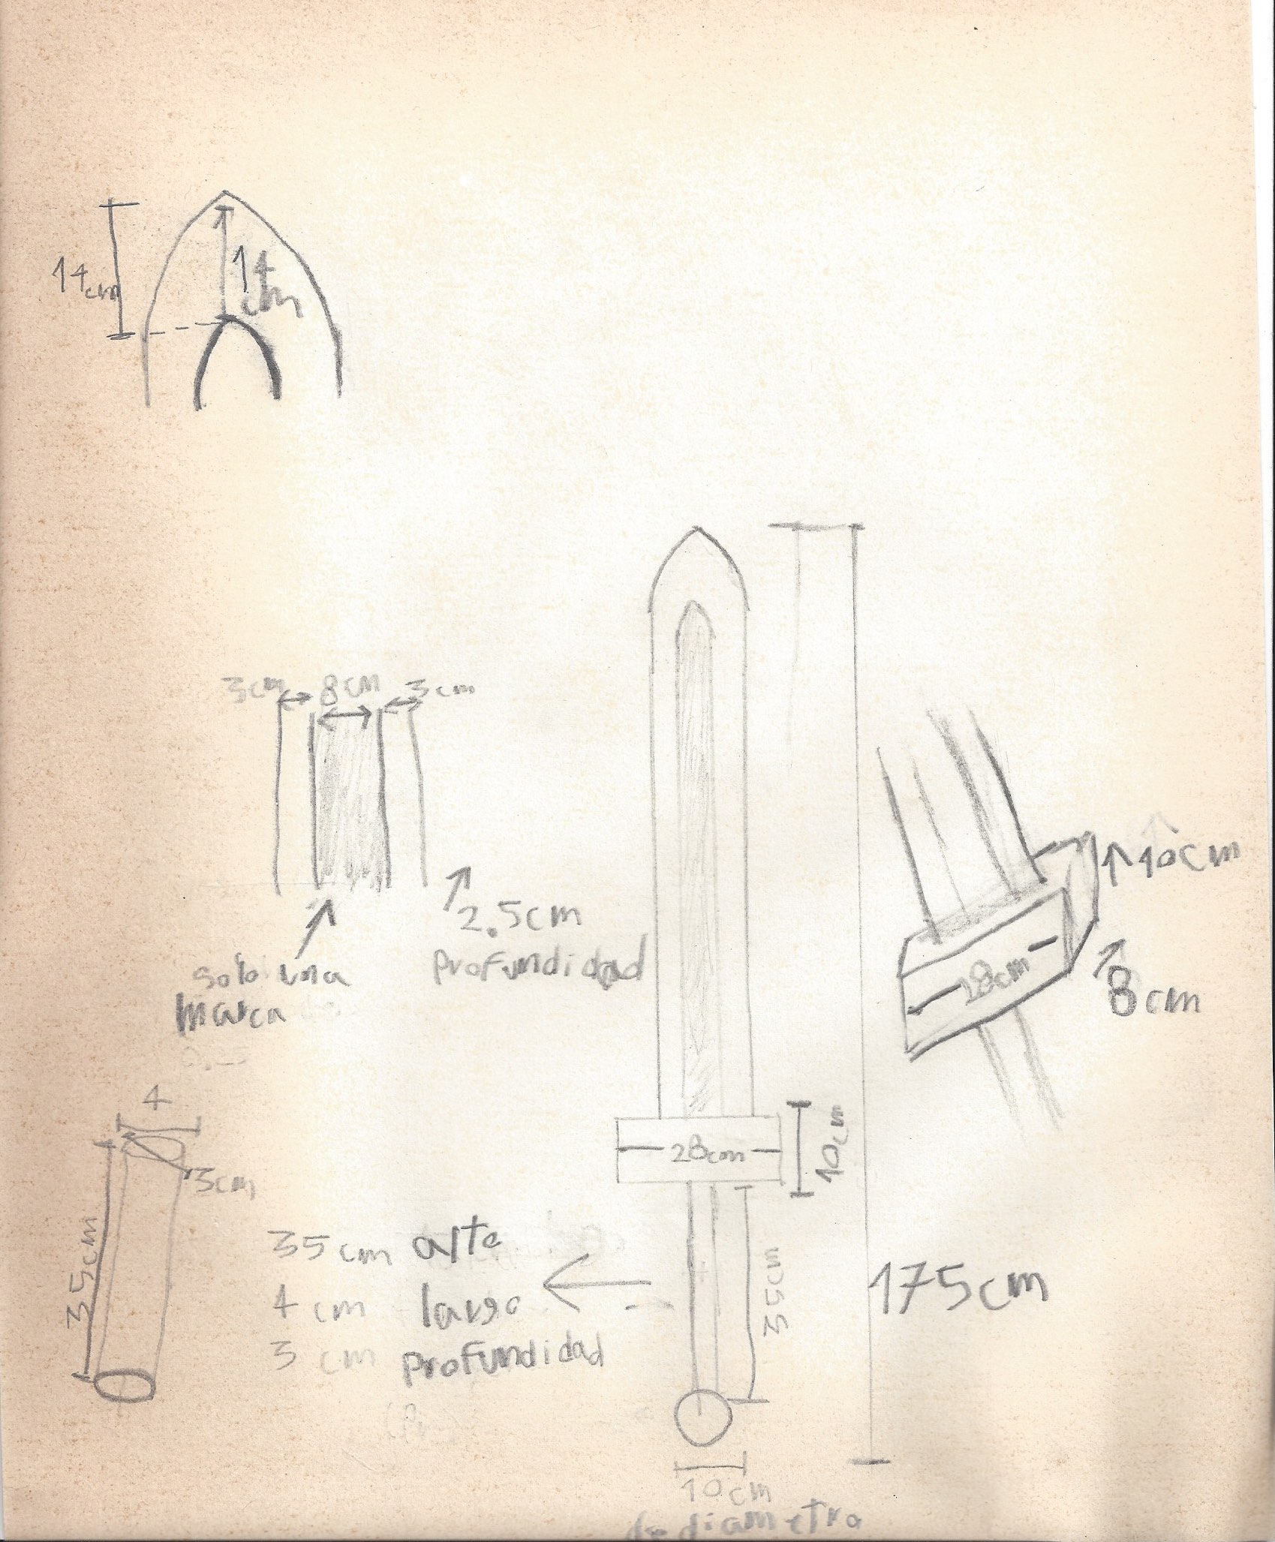 codigo en openscad
//sword pelial
translate([60,0,95]){
union() {
//--pome
sphere(5);
//--mango
translate([0,0,5]){
cylinder(h=35, r=1.7);
}
//--wings
translate([-14,-2,40]){
cube([28,4,8]);
}
//-- hoja
translate([-5,-1.25,48]){
cube([10,2.5,120]);
}
translate([-5,0,48]){
rotate([0,0,180])
cylinder(120,3,3,$fn=3);
}
translate([5,0,48]){
cylinder(120,3,3,$fn=3);
}
translate([-14,-2,40]){
}
//-punta
translate([0,1.25,172]){
rotate([90,-90,0])
cylinder(3,10,10,$fn=3);
}
}
}
//--me
translate([100,0,0]){
cube([60,20,172]);
}
translate([50,0,105]){
cube([170,10,10]);
}

antigua vs nueva
nueva 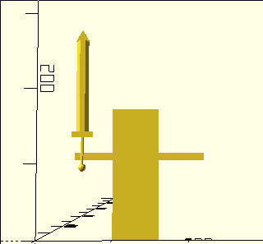 vieja 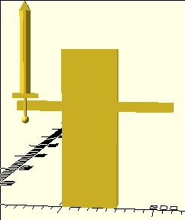

notas
https://www.youtube.com/watch?v=wqNjAFiH4CM
https://www.youtube.com/watch?v=dt2KZK3W1mo
ejercios
https://www.sword-buyers-guide.com/sword-fighting.html
una buena pagina para apreder y buscar
https://www.youtube.com/watch?v=cvMmlJF6zAg
como se pude practicar y medidas de precucion
canales que pueden ayudar
https://www.youtube.com/channel/UCqY4z_JKCBi18SZJV9vWjbA
https://www.youtube.com/channel/UCsBbd3QJ-IT2g8kSvq3r3RA/featured
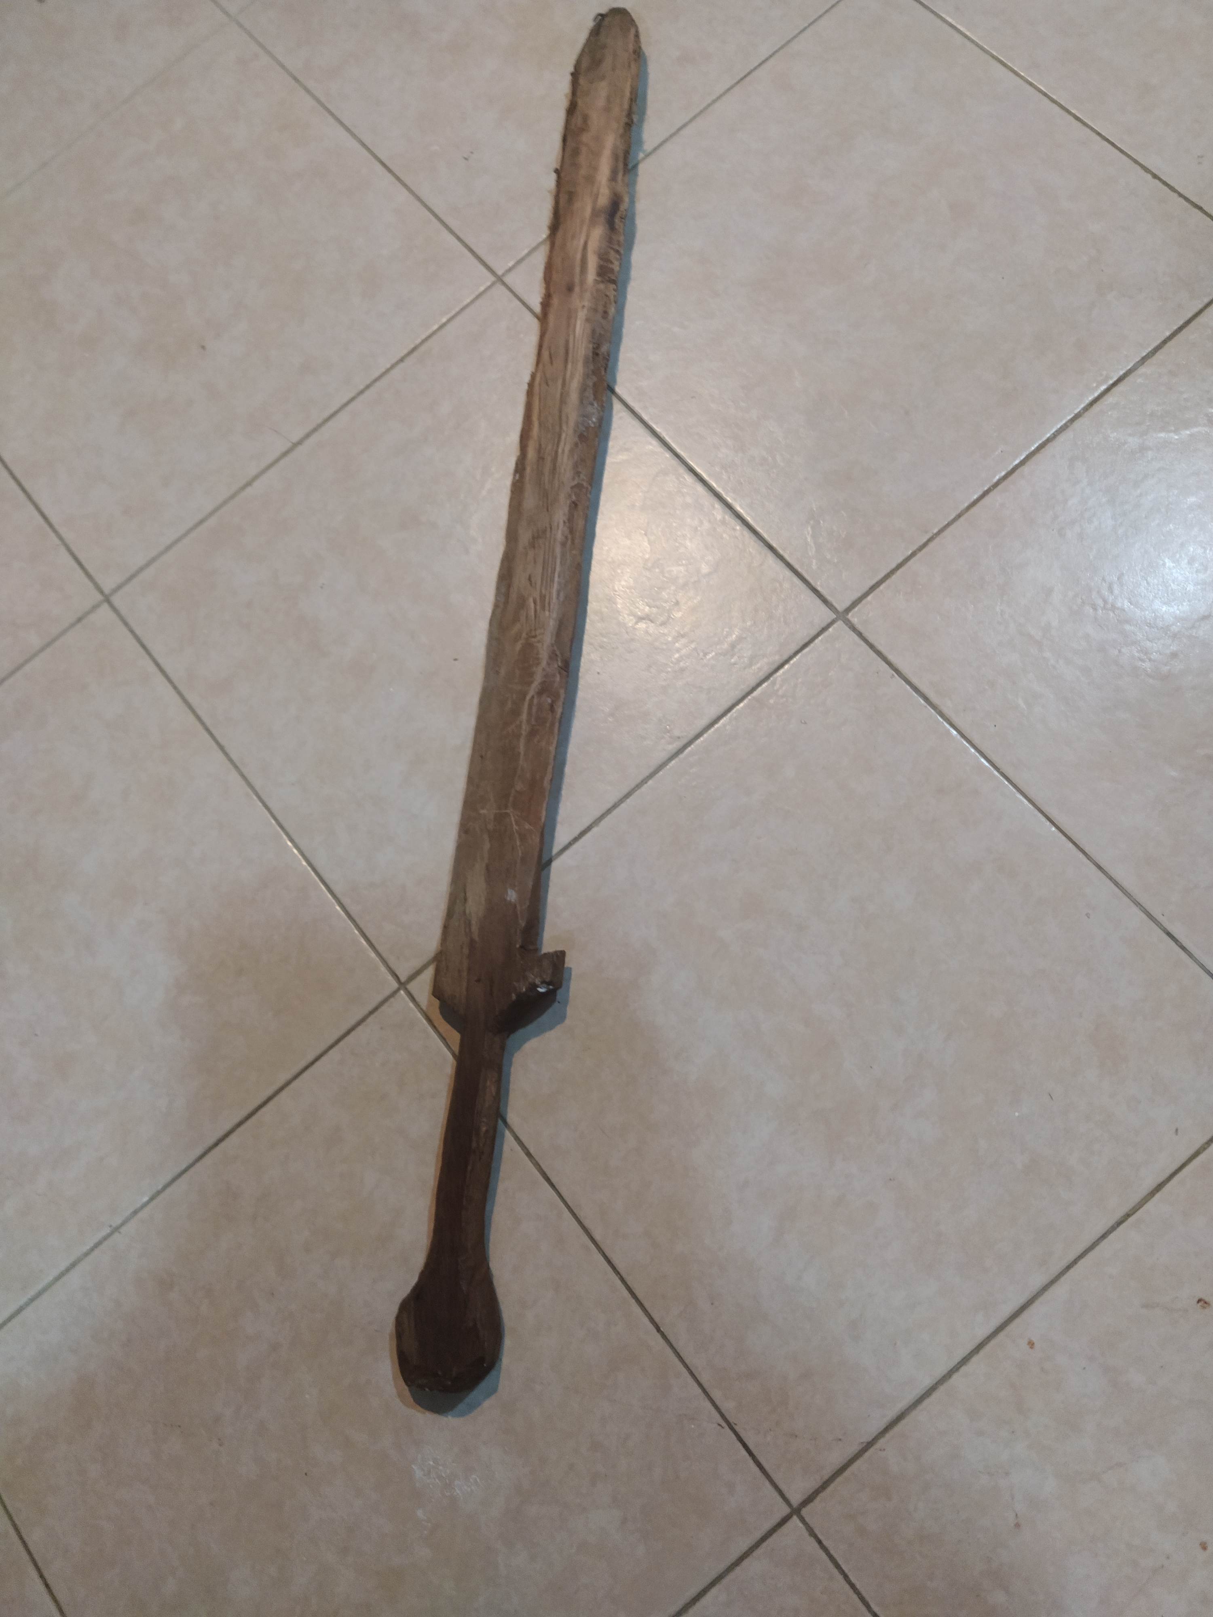
https://www.buyingasword.com/great-swords-2#/pageSize=12&orderBy=0
https://www.youtube.com/watch?v=HPqN_sx-0c4

