Conexión GPS al ESP8266

GPS L80
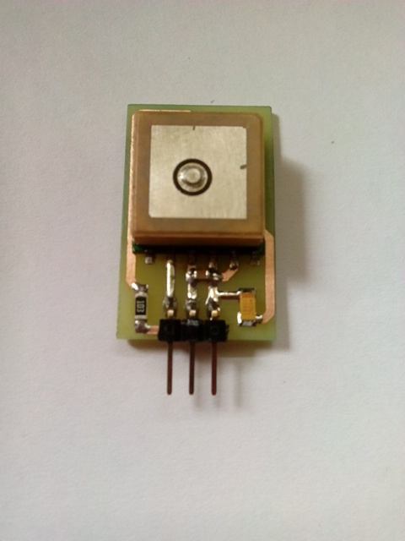
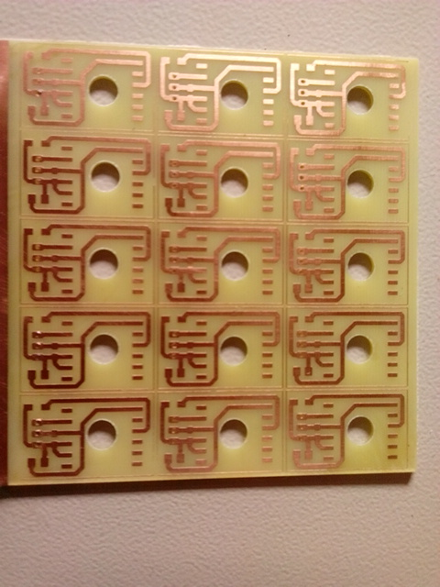
http://www.quectel.com/UploadImage/Downlad/L80_Hardware_Design_V1.1.pdf

Repositorio
https://github.com/unloquer/GPS_ESP

Usar FLASH del ESP
funciones spi_flash_write() → http://www.esp8266.com/viewtopic.php?f=9&t=1697 Memory mapping espressif SDK → http://bbs.espressif.com/viewtopic.php?t=698

Referentes
Escanea redes inalámbricas y guarda el log en un tarjeta SD → https://www.linuxpinguin.de/project/wifiscanner/

