El taller
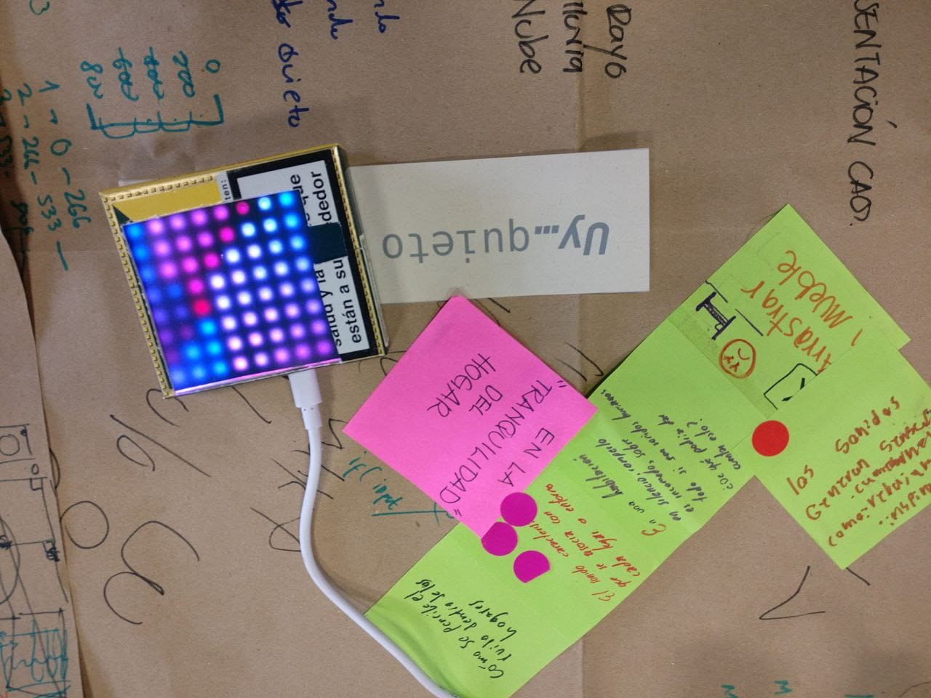 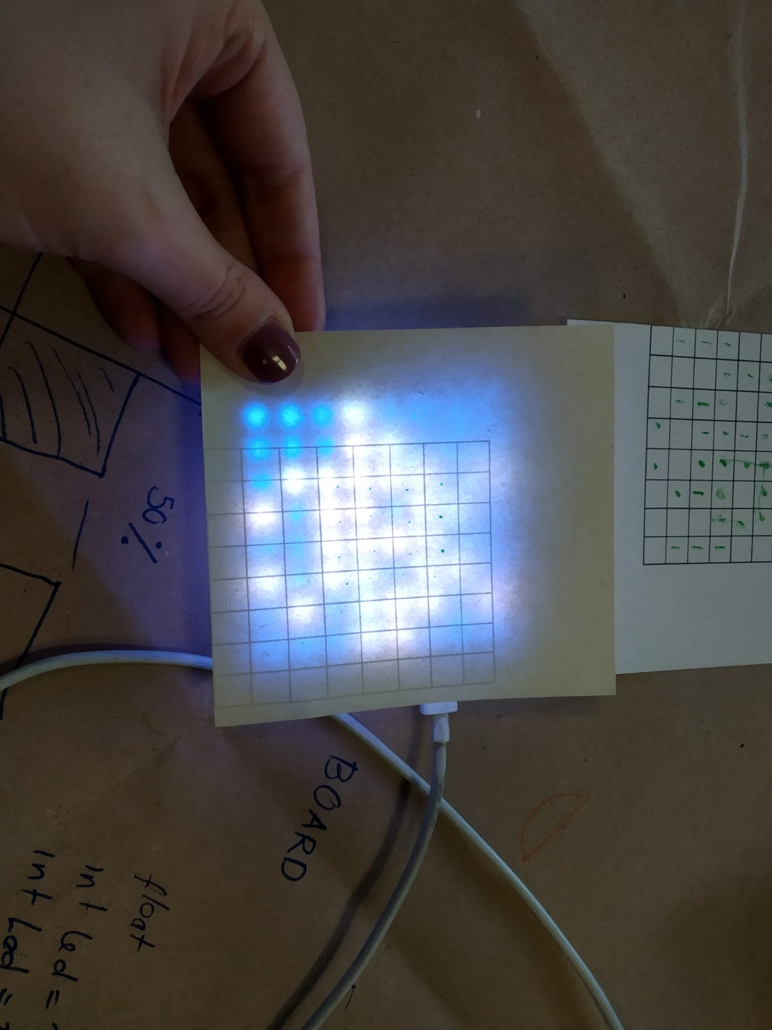 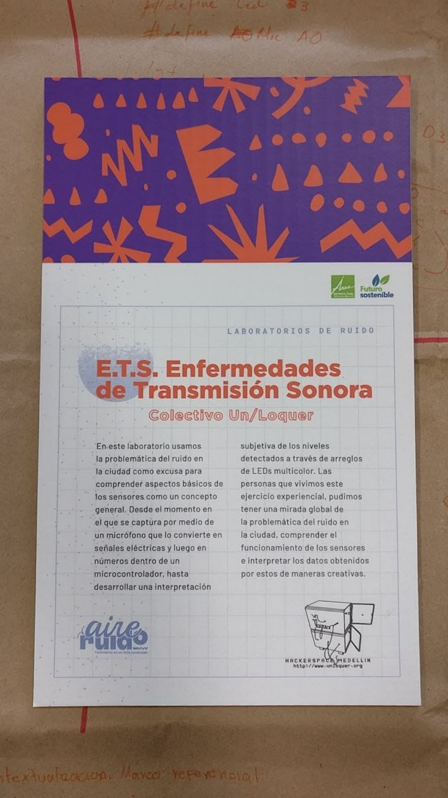 talleretsbibliosanjavier.mp4

Videos

Sesión 1
- concierto solenoide: https://www.youtube.com/watch?v=g_hiz-Kx0kM&list=PL341E603FB13FE2D3&ab_channel=reduzent
- Processing & Kinect Sensor: Finger Tracking + OSCP5 + Pure Data + Arp2600 https://www.youtube.com/watch?v=X5WGyJPS_5s
- Experimento de resonancia acustica: https://www.youtube.com/watch?v=wvJAgrUBF4w&ab_channel=brusspup
- Graffiti Laser: http://www.graffitiresearchlab.com/blog/projects/laser-tag/
- Delicate boundaries: http://csugrue.com/delicateboundaries/
- Licuadora que funciona con gruñidos:https://youtu.be/6DDkwdPaYmk
- Almacenador de gritos: https://youtu.be/Ta7rN5TeKzw
- Drawdio: https://www.youtube.com/watch?v=Ein9asQgfB8 y https://www.youtube.com/watch?v=HYg8iycYZNs&t=2s
- sensor pez: https://twitter.com/unloquer/status/1099095464291508224
- planta feliz: https://www.youtube.com/shorts/YAsNIonSBac
- juego de cubos en una caja :https://www.youtube.com/shorts/YZ7aAG4DWZk
- pelotica:https://www.youtube.com/shorts/9eLff37aS4U
- pez automata:https://youtu.be/HH9lDf5W-gU
- concierto de 8bits: https://youtu.be/nE3JVpOwWuU
- Lista de reproduccion: https://www.youtube.com/playlist?list=PL36dJutVa9QZj95urcHqORXl1mH-VnsEN
- galería de algunos sensores:https://twitter.com/jero98772/status/1383031921484165120
- multimedia de jugetes: https://wiki.unloquer.org/personas/jero98772/taller_explora/multimedia
- Taller de aire y vestuario: https://www.flickr.com/photos/37012247@N06/49257858968/

Sesión 2
Para generar ideas:
Sensores de calidad del aire y weareables: https://youtu.be/8ZFxrDkVOFk

Fanzine con manual de instalación
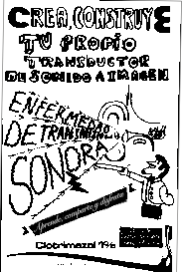
sin_titulo.pdf

Sesión 3
Para crear los conceptos:
Comprender el mundo a través de los datos:
¿Para que sirven los datos?
https://www.behance.net/gallery/82992729/Dear-Data-Postcard
http://www.visualcomplexity.com/vc/project_details.cfm?id=666&index=27&domain=Music

Componentes

ESP 8266
https://bigl.es/content/images/2018/10/Wemos-D1-Mini.png
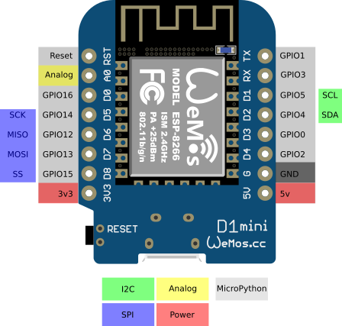

Micrófono

Info del Micrófono
https://maxelectronica.cl/3891-thickbox_default/modulo-max9814-sensor-de-sonido-microfono-electret-20-20khz.jpg
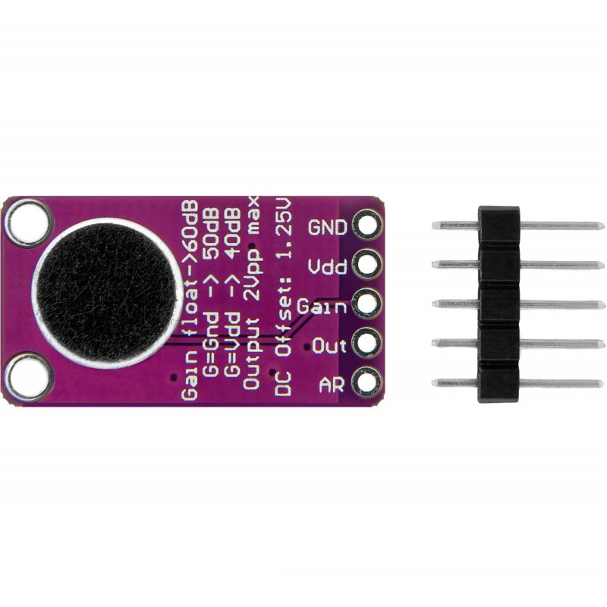

Amplificador
https://www.maximintegrated.com/en/products/analog/audio/MAX9814.html

Matriz de leds
https://img.bestdealplus.com/ae04/kf/H0a03f4ded2694b5f8ec2324c68521a6b5.jpg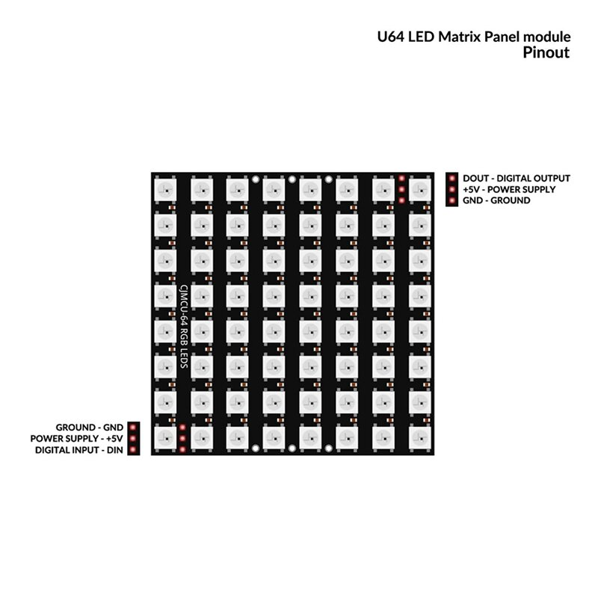

Aplicación Android
https://play.google.com/store/apps/details?id=name.antonsmirnov.android.arduinodroid2&hl=es&gl=CO

Entorno para desktop
Windows:https://www.arduino.cc/en/software

Github y Código
Repositorios de github: https://github.com/unloquer/ETSesnor
Repositorio del código sesión 2: intensidad
https://github.com/unloquer/ETSesnor/blob/main/src/src.ino
Descargar repositorio codigo para programar una “imagen” en la matriz
https://github.com/unloquer/ETSesnor

Ejemplo básico
#include <FastLED.h>
#define LED_PIN D3
#define LED_TYPE WS2812B
#define COLOR_ORDER GRB
#define amarillo CRGB::Yellow
#define negro CRGB::Black
#define rojo CRGB::Red
#define azul CRGB::Blue
#define maplv1 0x00FF00
#define maplv2 0x00AA00
#define maplv3 0xFFFF00
#define maplv4 0xFFE994
#define maplv5 0xFFAA00
#define maplv6 0xEC9BA4
#define maplv7 0xE1AA00
#define maplv8 0xFF00FF
#define maplv9 0x00DAFE
#define maplv10 0x0181FE
const uint8_t matrixWidth = 8;
const uint8_t matrixHeight = 8;
#define NUM_LEDS (matrixWidth * matrixHeight)
int BRIGHTNESS = 60;
CRGB leds[matrixWidth * matrixHeight];
int loop_cnt = 0;
const int sampleWindow = 50; // Sample window width in mS (50 mS = 20Hz)
unsigned int sample;
void setup() {
Serial.begin(115200);
LEDS.addLeds<LED_TYPE,LED_PIN,COLOR_ORDER>(leds,NUM_LEDS);
FastLED.setBrightness(BRIGHTNESS);
}
#define ESCENAS 1
CRGB matrix[ESCENAS][8][8] = {
{
{azul, azul, azul,azul, azul, azul, azul,azul},
{azul, azul, azul,azul, azul, azul, azul,azul},
{azul, azul, azul,azul, azul, azul, azul,azul},
{azul, azul, azul,azul, azul, azul, azul,azul},
{azul, azul, azul,azul, azul, azul, azul,azul},
{azul, azul, azul,azul, azul, azul, azul,azul},
{azul, azul, azul,azul, azul, azul, azul,azul},
{azul, azul, azul,azul, azul, azul, azul,azul},
},
};
void loop() {
for(int i = 0; i< matrixHeight; i++) {
for(int j = 0; j< matrixWidth; j++) {
leds[i*matrixWidth + j] = matrix[loop_cnt%ESCENAS][i][j];
}
}
unsigned long startMillis = millis(); // Start of sample window
unsigned int peakToPeak = 0;
unsigned int signalMax = 0;
unsigned int signalMin = 1024;
// collect data for 50 mS
while (millis() - startMillis < sampleWindow)
{
sample = analogRead(0);
if (sample < 1024) {
if (sample > signalMax)
{
signalMax = sample;
}
else if (sample < signalMin)
{
signalMin = sample;
}
}
}
peakToPeak = signalMax - signalMin;
int changeBrightness = map(peakToPeak, 20, 500, 0, 100);
FastLED.setBrightness(changeBrightness);
FastLED.show();
Serial.println(peakToPeak);
loop_cnt++;
FastLED.clear();
}

Librería para escribir en la matriz

#include <Arduino.h>
#include <FastLED.h>
#include <algorithm>
#define LED_PIN D3
#define LED_TYPE WS2812B
#define COLOR_ORDER GRB
/*
**
** https://github.com/FastLED/
** https://github.com/gmoehrke/FastFX
** https://www.reddit.com/r/FastLED/wiki/index/user_examples
** https://macetech.github.io/FastLED-XY-Map-Generator/
**
*/
#define amarillo CRGB::Yellow
#define negro CRGB::Black
#define rojo CRGB::Red
#define azul CRGB::Blue
#define morado CRGB::Purple
#define naranja CRGB::OrangeRed
#define verde CRGB::Green
#define aguamarina CRGB::Cyan
#define rosado CRGB::Fuchsia
#define verdedos CRGB::LimeGreen
#define raro CRGB::DarkOrchid
#define rarodos CRGB::DeepPink
#define maplv1 0x00FF00
#define maplv2 0x00AA00
#define maplv3 0xFFFF00
#define maplv4 0xFFE994
#define maplv5 0xFFAA00
#define maplv6 0xEC9BA4
#define maplv7 0xE1AA00
#define maplv8 0xFF00FF
#define maplv9 0x00DAFE
#define maplv10 0x0181FE
const uint8_t matrixWidth = 8;
const uint8_t matrixHeight = 8;
#define NUM_LEDS (matrixWidth * matrixHeight)
int BRIGHTNESS = 10;
CRGB leds[matrixWidth * matrixHeight];
const int sampleWindow = 50; // Sample window width in mS (50 mS = 20Hz)
unsigned int sample;
class Matrix {
CRGB *leds = NULL;
uint8_t numLeds = 0;
uint8_t currBrightness = 0;
public:
Matrix(CRGB *initLeds, uint8_t initNum) {
leds = initLeds;
numLeds = initNum;
}
// fill all matrix with same color
void fill(CRGB color) {
for (int i = 0; i < 64; i++) {
leds[i] = color;
}
};
// fill a binary shape with same color
// {
// B00000000,
// B10101010,
// B00000000,
// B10101010,
// B00000000,
// B10101010,
// B00000000,
// B10101010
// };
void fill(CRGB color, byte *shape) {
for (int i = 0; i < matrixHeight; i++) {
for (int j = 0; j < matrixWidth; j++) {
if (shape[i] & 1 << j) { // if bitwise AND resolves to
leds[i * matrixHeight + j] = color; // send 1
}
}
}
};
// fill color shape
void fill(CRGB color_shape[][8]) {
for (int i = 0; i < matrixHeight; i++) {
for (int j = 0; j < matrixWidth; j++) {
leds[i * matrixHeight + j] = color_shape[i][j]; // send 1
}
}
};
// fill row with color
void fill_y(CRGB color, int row) {
for (int j = 0; j < matrixWidth; j++) {
leds[row * matrixHeight + j] = color; // send 1
}
};
void fill_y_until(CRGB color_shape[][8], int until) {
for (int i = 0; i < until; i++) {
for (int j = 0; j < matrixWidth; j++) {
leds[i * matrixHeight + j] = color_shape[i][j]; // send 1
}
}
};
// fille column with color
void fill_x(CRGB color, int column) {
for (int i = 0; i < matrixHeight; i++) {
leds[i * matrixHeight + column] = color; // send 1
}
};
void fill_x_until(CRGB color_shape[][8], int until) {
for (int i = 0; i < matrixHeight; i++) {
for (int j = 0; j < until; j++) {
leds[i * matrixHeight + j] = color_shape[i][j]; // send 1
}
}
};
// of array in matrix
int sound_scale(); // return the actual level of sound intensity
void color_scale(int sl); // return color for 10 levels of sound intensity
};
Matrix *mym;
byte sshape[8] = {B00000000, B10101010, B00000000, B10101010,
B00000000, B10101010, B00000000, B10101010};
CRGB matrix[8][8] = {
{maplv2, maplv2, negro, negro, negro, negro, negro, negro},
{maplv3, maplv3, maplv3, negro, negro, negro, negro, negro},
{maplv4, maplv4, maplv4, maplv4, negro, negro, negro, negro},
{maplv5, maplv5, maplv5, maplv5, maplv5, negro, negro, negro},
{maplv6, maplv6, maplv6, maplv6, maplv6, maplv6, negro, negro},
{maplv7, maplv7, maplv7, maplv7, maplv7, maplv7, maplv7, negro},
{maplv8, maplv8, maplv8, maplv8, maplv8, maplv8, maplv8, maplv8},
{maplv9, maplv9, maplv9, maplv9, maplv9, maplv9, maplv9, maplv9},
};
unsigned int sample_sound() {
unsigned long startMillis = millis(); // Start of sample window
unsigned int peakToPeak = 0;
unsigned int signalMax = 0;
unsigned int signalMin = 1024;
// collect data for 50 mS
while (millis() - startMillis < sampleWindow) {
sample = analogRead(0);
if (sample < 1024) {
if (sample > signalMax) {
signalMax = sample;
} else if (sample < signalMin) {
signalMin = sample;
}
}
}
peakToPeak = signalMax - signalMin;
return peakToPeak;
}
void setup() {
Serial.begin(115200);
LEDS.addLeds<LED_TYPE, LED_PIN, COLOR_ORDER>(leds, NUM_LEDS);
mym = new Matrix(leds, 64);
FastLED.setBrightness(BRIGHTNESS);
}
void loop() {
int sample = sample_sound();
// tomado de https://forum.arduino.cc/t/map-but-log/379910/3
int logmaplv = log(sample + 1) / log(900) * 9;
Serial.println(logmaplv);
for (int i = 0; i <= logmaplv; i++) {
mym->fill_y_until(matrix, i);
FastLED.show();
FastLED.delay(30);
}
FastLED.clear();
}

Diagrama electronico
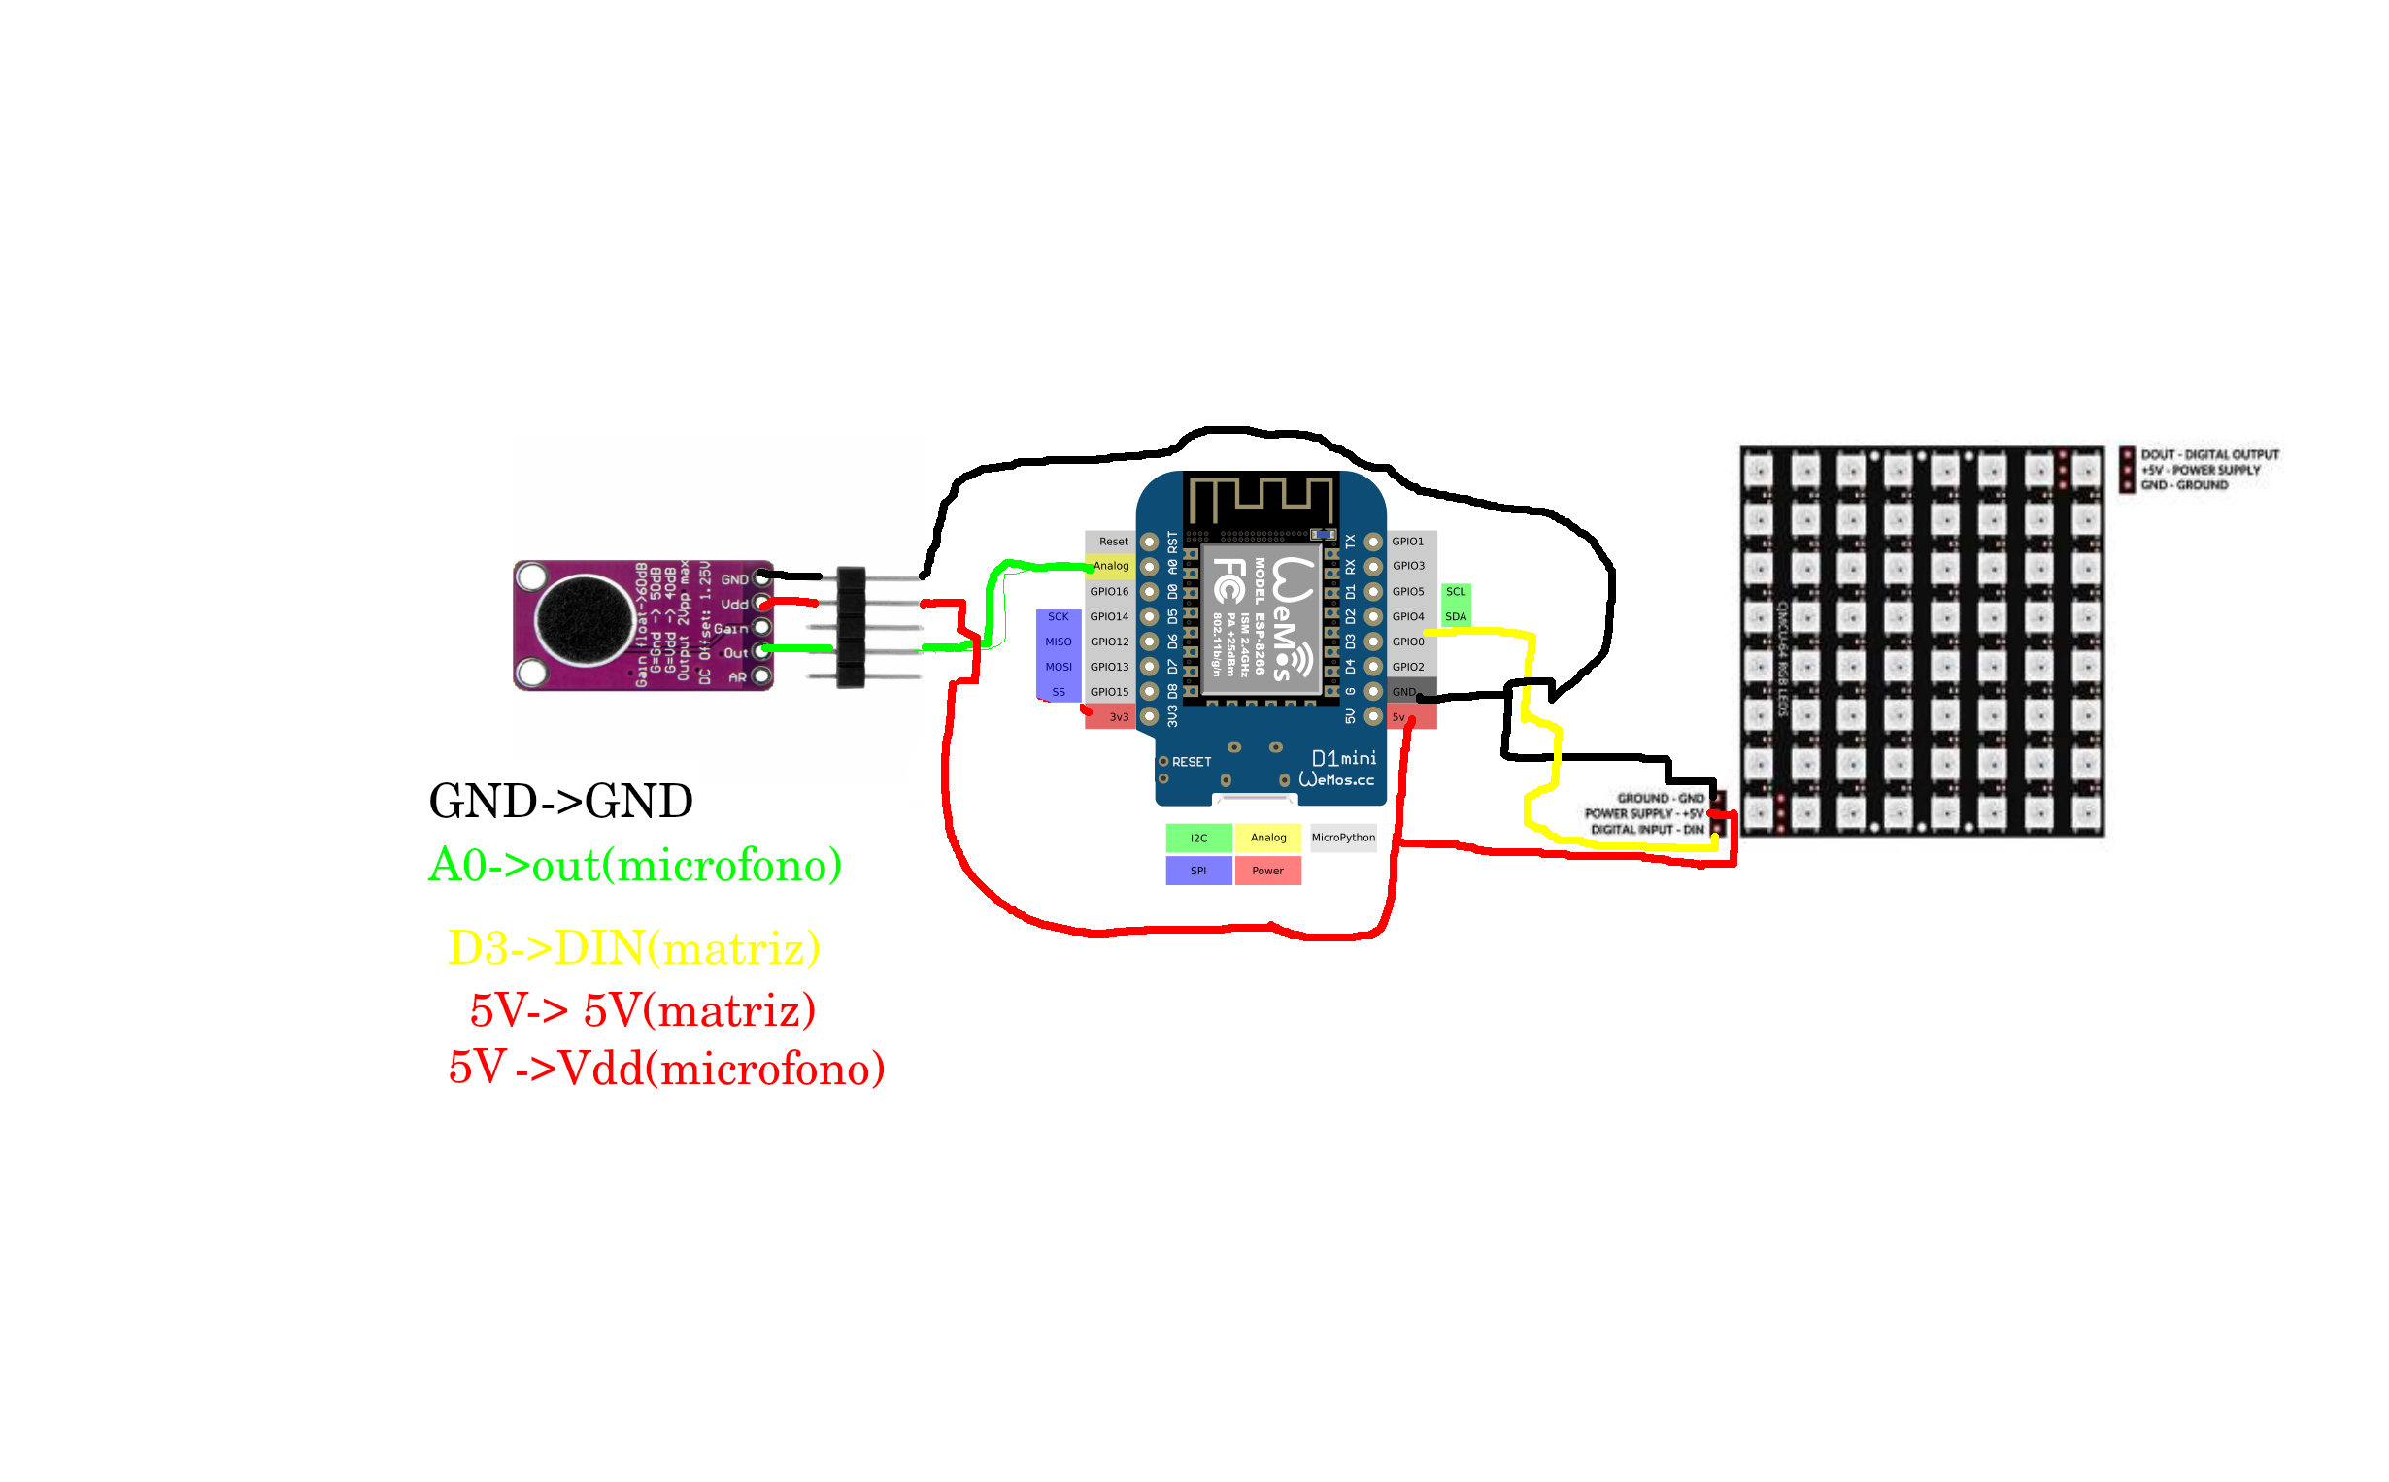
Descargar repositorio codigo para programar varios estados en la matriz

Referentes
- https://www.reddit.com/r/FastLED/wiki/index/user_examples
- https://connornishijima.github.io/Pixie_Chroma/?section=shortcodes

Contacto
https://t.me/unloquer

